Title page

186 steps
Introduction

Quarrying has the ability to both face and deface. In Wirksworth’s past history, the quarry and its works have sculptured the town. Today, the town uses the spaces created by its past industry as an asset and for sculpture.

A short walk in the town, between Middleton Road and Greenhill, lifts you over a remaining cliff face, from where you can see the sheer drop either side into the remains of the Quarry. Continue the walk back towards the town centre, you will pass Bambington House.

At the rear of this house, a sheer cliff is exposed, which frames the house and its gardens. This reveals the raw rock face of Wirksworth, often hidden behind houses.

Some months ago, My wife and I were holidaying in Salzburg, Austria. A 90 minute flight from East Midlands airport. From Salzburg, a short drive east takes you to the Industrial town of Linz. If Derby were Linz, then Wirksworth would be Mauthausen. A small country town in Upper Austria, which has also been faced and defaced by a quarry.

Mauthausen also has a past. It was one of the most formidable concentration camps of the Second World War. Today it is a tranquil place of peace. Its gardens now host sculptures from many countries, whose citizens fell into Mauthausen during those years.

A path from the camp, down 186 steps, takes you into the Quarry at Mauthausen. Here, the prisoners were forced to work until they died. The 186 steps gained notoriety, as the only path out of the quarry. Quarried rock had to be manually carried out by the labourers. These steps saw the deaths of many prisoners.

Today, the 186 steps and the quarry at Mauthausen have a peace.

When we first saw the garden at Bambington House, the recollection of walking into the quarry at Mauthausen struck instantly. The scale is much smaller, however the cliff face is something that had an immediate impact.

I could see where the 186 steps should be.

I am proposing a temporary structure, which will give a scaled impression of the 186 steps at Mauthausen, within the gardens at Bambington House. This structure will have 186 “steps”, leading a curving walkway of blue light from the base of the “quarry” up to the face of the cliff in the garden.

My intention is that the structure will pay homage to the forced labourers at Mauthausen, that it will offer a way out of the quarry for them, and to provoke the observer into typing “186 steps” into Google.

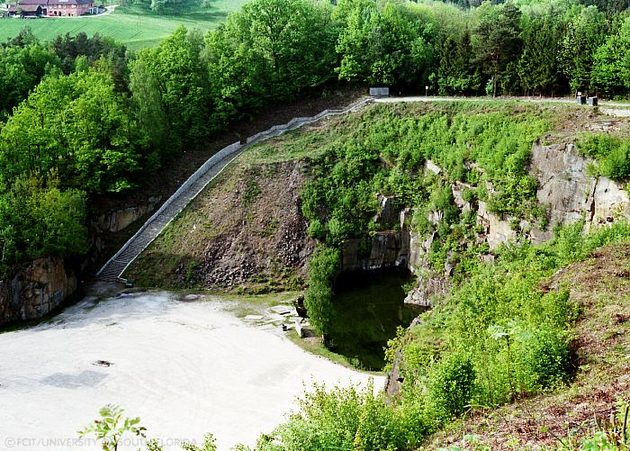 186 Quarry Steps at Mauthausen

Technical Information

The entire sculpture will be modular in construction. This will give the project the advantage of being able to be constructed in “modules” away from the proposed site. This will minimise time working at the site, plus it will be easier to break down, transport, store and be reconstructed afterwards.

The supporting framework of the “186 Steps” assembly will consist of a square box “rail” using Galavanised Steel Box Trunking. This rail is built in three “modules”, which interconnect and form a stepped curved rise at 45 degrees from the floor of the site, to the cliff face. The rail will be permanently fixed at the base to an angle iron stake, driven into the ground to provide stability. The upper module of the rail will be fixed to the cliff face in two places, using either spring camming devices (as used by rock climbers), or rock screws. It is important that these cliff face fixings are to leave no trace after the project is removed.

Each of the three “modules” will have 62 brackets attached. Each of these brackets will support a single Perspex “Step”, attached using two nuts & bolts per step to form the complete 186 steps when assembled together.

The modules are interconnected with a 45 degree horizontal bend, to imitate the “sweep” of the Mauthausen 186 steps.

The end of the top module will have an end cap, finished with a weatherproof seal

Every second step will have an attached “Cold Cathode Fluorescent Light” (CCFL). These lights give an intense bright blue glow, easily visible in bright daylight. The lights have an inbuilt acrylic diffuser.

The CCFLs run via a 12v DC Inverter, which controls two CCFL each. These inverters will be fixed within each “module”. Cabling will be hidden within the galvanised steel trunking.

12V DC will be supplied to the base of the framework via three 12v DC transformers (for redundancy). Outdoor electrical cabling will be hidden, initially under turf, then via a cable run to a mains connection in the garden, approx 25 metres away. All circuits are to be protected by Earth Leakage Circuit Breakers (ELCB’s) for safety. It is intended that power to the entire project will be switched on/off from inside the house. This will ensure that there has to be an occupant inside the house when power is applied to the construction.

The footprint of the “186 steps” will reach 2.7 metres from the cliff face. It will sweep through 1.6 metres before joining the cliff. Its upper point will finish at a point 4.2 metres high on the cliff.

A weatherproof “Information Board”, containing a description of the work with background information on Mauthausen’s 186 steps will be installed in a prominent place in the garden.

186 Steps. – Dimensions & Power Requirements

Each of the 3 stair “Modules” consists of Galvanised Steel Trunking, 2170 x 50 x 50 mm

An assembled “module” consists of 62 perspex “steps” 35mm apart. Each “step” is 315 x 100 x 5mm

Every second “step” houses a Blue Cold Cathode Fluorescent Light. 315 x 15 x 15mm

The CCFLs run via a 12v DC Inverter, servicing two lamps each. These lamps have a power requirement of approx 1w per unit. The total DC loading per “Module” of 31 lamps is fed by an individual 12V DC transformer per module. Each unit is capable of supplying 60 watts per unit, easily handling the power requirements for the lamps.

186 steps - Work Requirements & Site Access

Construction of the “186 steps” will be between Saturday 9th September and Thursday 14th September and will take place initially off site.

I have met David Grattige at Bambington House to explain the outline of this project, it’s requirement for power, it’s location and it’s possible acceptance.

Access to Bambington House will be required on at least one full day during this time, in order to lay cabling to the proposed site of installation. It is my intention to have the installation transported and erected at Bambington House by Thursday 14th September. This access will need to be at David Grattige’s convenience.

As the work is modular, it can be assembled on the ground. I will need access by ladder to fix the final part of the piece securely to the cliff wall. The highest point will reach 4.2 metres from the grass.

Final checks to the installation will need to be made on Friday 22nd September prior to the opening of the sculpture trail weekend on the 23rd.

Preliminary Sketches

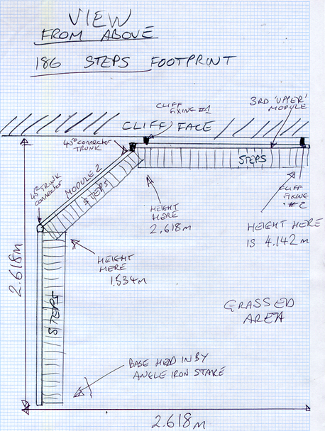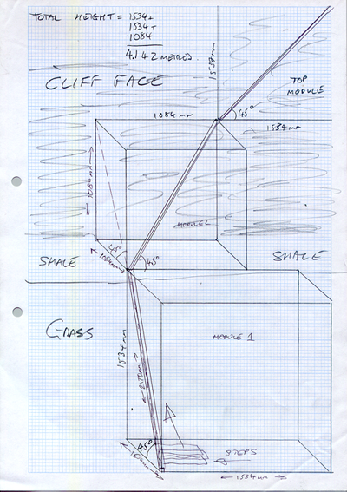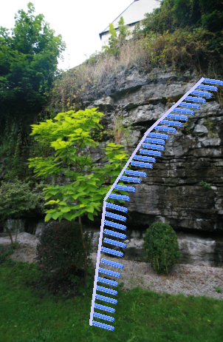

Materials Breakdown unit price

Angle Iron Stake Qty 1 £10.00
Galvanised Trunking, 50mm x 50mm, 3m lengths Qty 3 £12.45 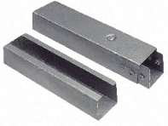
Top Lid 45 degree bend 50mm x 50mm Qty4 £3.65 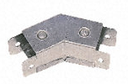
End Cap 50mm x 50mm Qty 1 £3.75 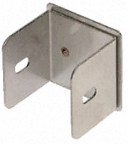
Cold Cathode Fluorescent Lights Qty 93 £157 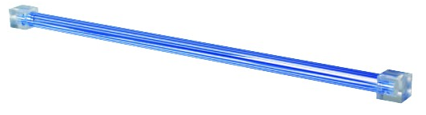
12v DC Lighting Transformer (@60Watts each) Qty 3 £2.95 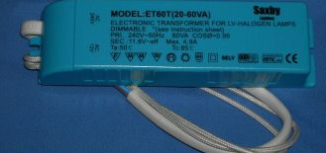
Perspex “Steps” Qty 186 £62.00 total 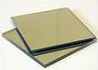

Sealant Qty 1 £15.00

50m Outdoor Cabling Qty 1 £25.00

+ Rock Fixings, either by climbing “Friends” (Spring loaded camming device), or alternative rock screw. (approx cost £10.00)

Total Cost of Project = £313.60

